Week 11 Homework

If you want to replicate these results, use Pallant_SLEEP3ED.sav

Problem 1.

RQ: How does working nightshifts and sleep quality combine to affect mood?

IV: Works nightshift (niteshft), sleep quality (qualslp)
DV: Mood

Source | Mean Square | F | df | Sig.
Niteshft | 4.836 | .866 | 1 | .354
Qualslp | 9.806 | 1.756 | 4 | .143
niteshft * qualslp | 13.771 | 2.466 | 3 | .066
Error | 5.584 |  | 113

- Write up the results of this analysis in APA format. (Remember there are three F tests so three results should be reported).
- Are any additional tests or statistics needed?

Problem 2.
RQ: How do problems with sleeping and age relate to scores on the Epworth Sleepiness Scale?

IV: problems with sleeping (probsleeprec) and age (age_groups)
DV: ESS scores

Tests of Between-Subjects Effects
Source | Mean Square | df | F | Sig.
Prob sleeping | 138.736 | 1 | 11.142 | 0.001
Age | 25.332 | 2 | 2.034 | 0.133
Prob sleep * Age | 5.281 | 2 | 0.424 | 0.655
Error | 12.452 | 226 | 12.452

- Write up the results of this analysis in APA format. (Remember there are three F tests so three results should be reported).
- Assume “problem sleeping” has a significant main effect. Use the descriptives table below to explain what the researchers found.

Descriptive Statistics
Dependent Variable: epworth sleepiness scale
prob sleep recode 01 | Age (3 groups) | Mean | Std. Deviation | N
no | <= 37 | 5.46 | 3.223 | 46
no | 38 – 50 | 5.92 | 3.571 | 51
no | 51+ | 6.65 | 3.743 | 37
no | Total | 5.96 | 3.510 | 134
yes | <= 37 | 6.83 | 3.510 | 35
yes | 38 – 50 | 8.10 | 3.633 | 30
yes | 51+ | 7.82 | 3.548 | 33
yes | Total | 7.55 | 3.567 | 98
Total | <= 37 | 6.05 | 3.398 | 81
Total | 38 – 50 | 6.73 | 3.725 | 81
Total | 51+ | 7.20 | 3.674 | 70
Total | Total | 6.63 | 3.613 | 232

Problem 3.
RQ: How do problems with sleeping and being a light sleeper relate to scores on the Epworth Sleepiness Scale?

IV: problems with sleeping (probsleeprec) and light sleeper (liteslp)
DV: ESS scores

Tests of Between-Subjects Effects
Source | Mean Square | df | F | Sig.
probsleeprec | 148.172 | 1 | 11.657 | 0.001
liteslp | 19.821 | 1 | 1.559 | 0.213
probsleeprec * liteslp | 62.419 | 1 | 4.910 | 0.028
Error | 12.711 | 248
a. R Squared = .069 (Adjusted R Squared = .058)

- Write up the results of this analysis in APA format. (Remember there are three F tests so three results should be reported).
- Assume there’s a significant interaction. What is the next step for analysis?
- Is this an ordinal or disordinal interaction?

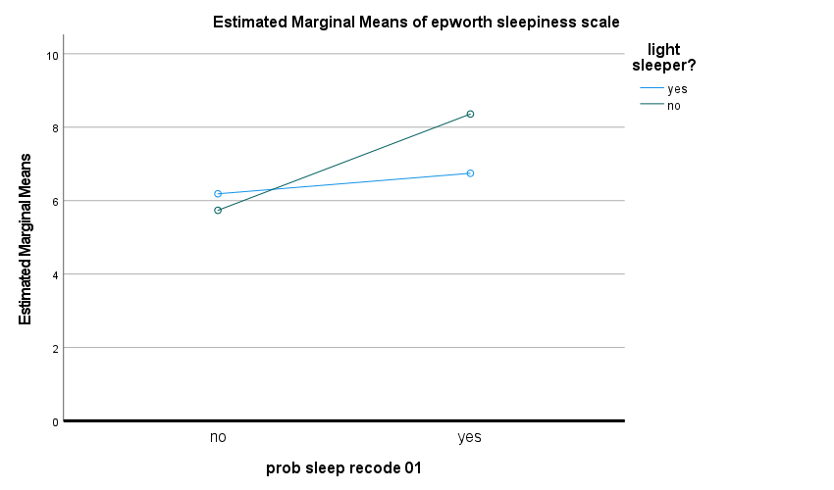

- Here is the output that follows the significant interaction. What do the results show? Describe the interaction’s effect.

ANOVA
prob sleeping |  | Mean Square | df | F | Sig.
no | Between Groups | 6.476 | 1 | 0.513 | 0.475
no | Within Groups | 12.622 | 141
no | Total |  | 142
yes | Between Groups | 70.523 | 1 | 5.497 | 0.021
yes | Within Groups | 12.829 | 107
yes | Total |  | 108

prob sleeping |  | N | Mean | SD
no | yes | 48 | 6.19 | 3.896
no | no | 95 | 5.74 | 3.368
no | Total | 143 | 5.89 | 3.547
yes | yes | 59 | 6.75 | 3.457
yes | no | 50 | 8.36 | 3.724
yes | Total | 109 | 7.49 | 3.656

